Nullptr*
Fight Night Finale
GAM150 Technical Document

Coding Conventions
- Namespaces use snake_case
- Classes and Functions use PascalCase
- Variables use camelCase
- Private and Protected variables must be prefixed with m_variableName

Code style
- NO TABS, two spaces
- Soft line limit of 120 characters
- Hard line limit of 150 characters
- Use #pragma region to group functions inside source files if there are a lot of functions

Source Control
We are using Gitlab as our source control, we have two principal branches:
- Main: the release and stable branch
- Dev: the active development branch
We also enforce the following rules:
- All pull requests need to be approved by any other member to merge.
- All pull requests must succeed the CI pipeline.
- Dev and Main are protected branches.
- You can only merge into Main with the approval of every member of the group.

Debugging Tools
We use Alpha engine’s implemented debug draw to help us in development, and the default windows console.
With Alpha engine’s debug text, we added the option to see what current resources are loaded and game objects present in the current scene.
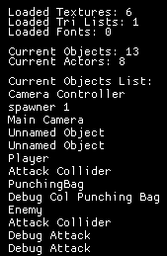

We also implemented an in-game simple profiler, which tells us what part of the game is taking the most time to process, dividing each part into: Collision, Tick, Draw and Sound.
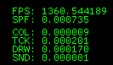
These debugging tools are disabled if compiling in release mode.

Graphics Overview
We are using Alpha engine’s built-in graphics, using OpenGL as a graphics API, we are unable to modify any shaders from Alpha.
Resource loading and managing is done via a Factory class, which tracks every texture, font, tri list and Game Object created to not load them into memory again by accident.

Behavior Overview
We are using simple state machines for the enemies, without pathfinding since the scenes are open and not too complex.

Multiplayer Overview
This game is meant to be played local coop, two players max, using keyboard and gamepad or two gamepads sharing the same screen, the camera will make sure both players stay in sight at the same time.

Art Pipeline

